# Test Designer

## Definition

**# Source**: **Chatgpt (GPT-5-Standard) at [8/22/2025]**

A **Test Designer** is responsible for **creating detailed test cases, test procedures, and test data** based on requirements, specifications, or user stories.

* Ensures that the tests **effectively validate the functionality, performance, and reliability** of the system.
* In ISTQB terms, the Test Designer may overlap with the **Test Analyst** role, focusing on **test specification and preparation**.

## Key Responsibilities

**# Source**: **Chatgpt (GPT-5-Standard) at [8/22/2025]**

1. **Test Case Design**
   * Develop **detailed test cases** from test conditions or requirements.
   * Specify **inputs, execution steps, and expected results**.
2. **Test Data Preparation**
   * Create the **data sets** needed for test execution.
3. **Test Coverage Verification**
   * Ensure all **requirements or user stories are covered** by test cases.
   * Maintain **traceability between requirements and tests**.
4. **Collaboration**
   * Work with **Test Analysts / Business Analysts / Developers** to clarify requirements.
   * Support **test execution teams** in understanding and executing tests.
5. **Review and Optimization**
   * Review test cases for **effectiveness and efficiency**.
   * Optimize tests to **maximize coverage with minimum effort**.

## Skills Required

**# Source**: **Chatgpt (GPT-5-Standard) at [8/22/2025]**

* Knowledge of **test design techniques** (boundary value analysis, equivalence partitioning, decision tables, state transition, etc.).
* Analytical skills to **interpret requirements accurately**.
* Ability to **prepare comprehensive test data**.
* Familiarity with **test management tools** (e.g., TestRail, JIRA, HP ALM).

## Deliverables / Outputs

**# Source**: **Chatgpt (GPT-5-Standard) at [8/22/2025]**

* **Detailed Test Cases**
* **Test Data Sets**
* **Traceability Matrix** (mapping requirements to test cases)
* **Test Procedures**

## Shortcut to Remember:

**# Source**: **Chatgpt (GPT-5-Standard) at [8/22/2025]**

**Test Designer = Create detailed test cases + prepare test data + ensure coverage**

✅ **Summary Note:** In ISTQB terminology, **Test Designer and Test Analyst roles often overlap**.

* **Test Analyst:** Focuses on **what to test** (test conditions/scenarios).
* **Test Designer:** Focuses on **how to test** (detailed test cases and data).

## Difference between Test Analyst and Test Designer

**# Source**: **Chatgpt (GPT-5-Standard) at [8/22/2025]**

Here’s a clear explanation of the **difference between Test Analyst and Test Designer** in ISTQB terms:

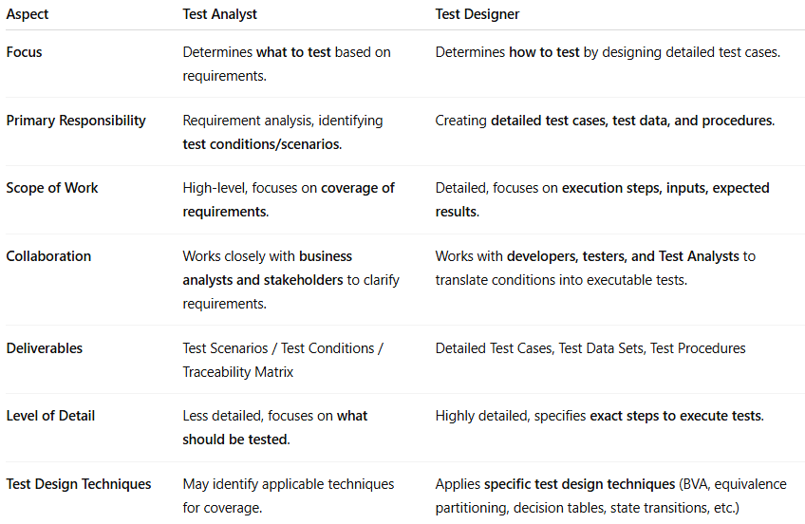

| **Aspect** | **Test Analyst** | **Test Designer** |
| --- | --- | --- |
| **Focus** | Determines **what to test** based on requirements. | Determines **how to test** by designing detailed test cases. |
| **Primary Responsibility** | Requirement analysis, identifying **test conditions/scenarios**. | Creating **detailed test cases, test data, and procedures**. |
| **Scope of Work** | High-level, focuses on **coverage of requirements**. | Detailed, focuses on **execution steps, inputs, expected results**. |
| **Collaboration** | Works closely with **business analysts and stakeholders** to clarify requirements. | Works with **developers, testers, and Test Analysts** to translate conditions into executable tests. |
| **Deliverables** | Test Scenarios / Test Conditions / Traceability Matrix | Detailed Test Cases, Test Data Sets, Test Procedures |
| **Level of Detail** | Less detailed, focuses on **what should be tested**. | Highly detailed, specifies **exact steps to execute tests**. |
| **Test Design Techniques** | May identify applicable techniques for coverage. | Applies **specific test design techniques** (BVA, equivalence partitioning, decision tables, state transitions, etc.) |

✅ Key Point

* **Test Analyst = What to test** → Focuses on requirements and conditions.
* **Test Designer = How to test** → Focuses on detailed cases, data, and procedures.

In many organizations, **the two roles overlap**, and sometimes the same person performs both activities.